You are given the root node of a binary search tree (BST) and a value to insert into the tree. Return *the root node of the BST after the insertion*. It is **guaranteed** that the new value does not exist in the original BST.

**Notice** that there may exist multiple valid ways for the insertion, as long as the tree remains a BST after insertion. You can return **any of them**.

**Example 1:**

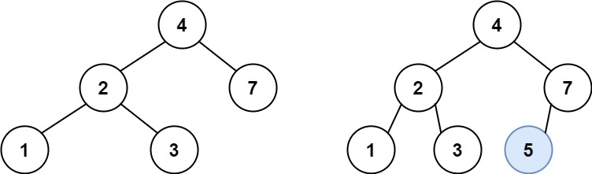

**Input:** root = [4,2,7,1,3], val = 5

**Output:** [4,2,7,1,3,5]

**Explanation:** Another accepted tree is:

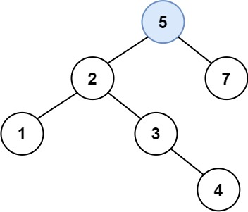

**Example 2:**

**Input:** root = [40,20,60,10,30,50,70], val = 25

**Output:** [40,20,60,10,30,50,70,null,null,25]

**Example 3:**

**Input:** root = [4,2,7,1,3,null,null,null,null,null,null], val = 5

**Output:** [4,2,7,1,3,5]

**Constraints:**

* The number of nodes in the tree will be in the range [0, 104].
* -108 <= Node.val <= 108
* All the values Node.val are **unique**.
* -108 <= val <= 108
* It's **guaranteed** that val does not exist in the original BST.